**Part 1 - Artificial Neural Networks!**

In this part you will learn:

1. The Intuition of ANNs
2. How to build an ANN
3. How to predict the outcome of a single observation (Homework Challenge)
4. How to evaluate the performance of an ANN with k-Fold Cross Validation
5. How to tackle overfitting with Dropout
6. How to do some Parameter Tuning on your ANN to improve its performance

The neuron:

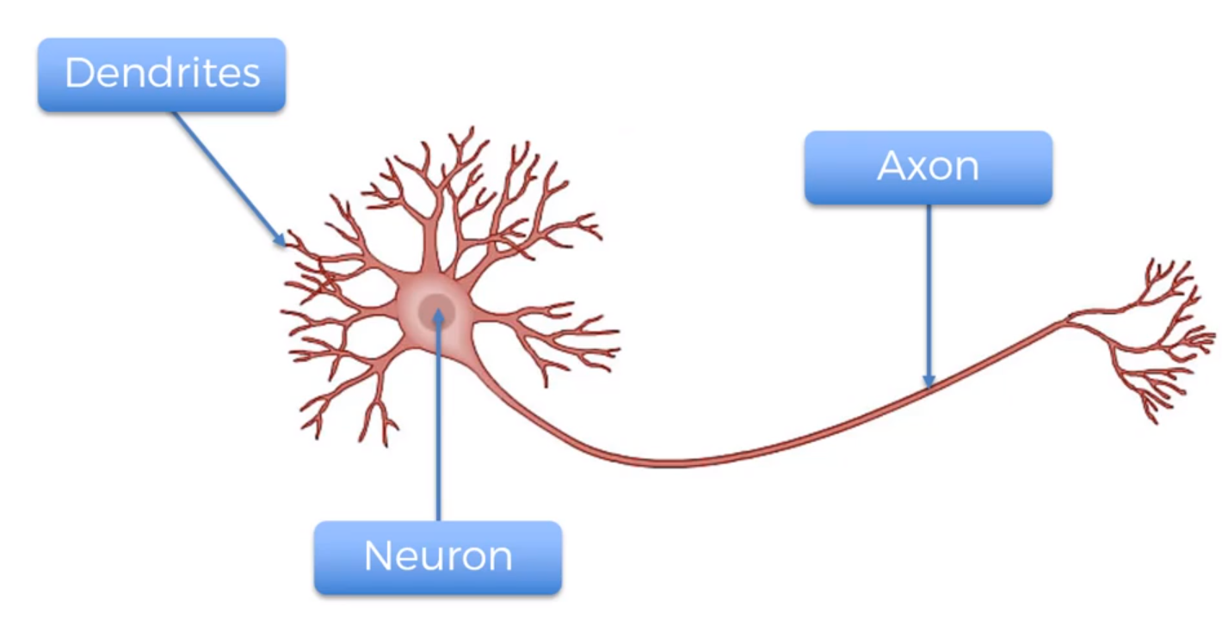

Dendrites are the receiver of the Signals. Axon are the transmitter of the Signals.